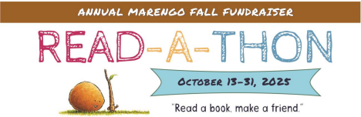Dear Marengo Parents,

Welcome to our Fall PTA Fundraiser! During Read-a-Thon, the whole school comes together to encourage reading and build good habits, while also raising money to support PTA programs at Marengo.

**How the Read-a-Thon works**

Each day from October 13 - 31, your child will record how many minutes they read in total on their paper reading log. Any reading time outside of school counts: from chapter books to graphic novels to magazines. Younger children can also count the time someone else reads to them. This year’s theme: “Read a Book, Make a Friend,” is all about reading together. Reading groups, book swaps, and reading parties are highly encouraged!

At the end of the Read-a-Thon, the leading readers in each grade will be announced at a ROAR assembly. They will receive a small prize and the opportunity to make a personal book recommendation displayed in the school library!

**How we raise money**

Students can raise money for the school by being sponsored - either with a flat donation or with a small donation per minute. Marengo students typically read between 400 and 1500 minutes total during the three weeks, which would be $20 - $75 if they were sponsored at a nickel per minute.

Find your student’s page on [99Pledges](https://app.99pledges.com/fund/marengoreadathon25) to manage sponsors and donations. You can also drop off a donation at the front office in an envelope with the student’s name. Use the QR code below or go to: <https://app.99pledges.com/fund/marengoreadathon25>. We encourage you to share your student’s page with family and friends! All donations are tax-deductible and donors will receive an email receipt with tax information. Donations can also be eligible for company matching! If you have a company matching donation, please contact readthon@marengopta.org to ensure it is counted toward our fundraising goal.

**The bookmark contest**

Students are also encouraged to design a bookmark celebrating this year’s theme. Mrs. Becker, school librarian, will select two winning designs, which will be printed and distributed to all students in November. The bookmark contest ends Oct. 31.

If you have any questions, please contact [readathon@marengopta.org](mailto:readathon@marengopta.org).

**Thank you and happy reading!  
Peter Lifland - Marengo Readathon Chair**